Visualize scene captured from Ouster lidar

- Download Ouster Visualizer - https://ouster.com/downloads
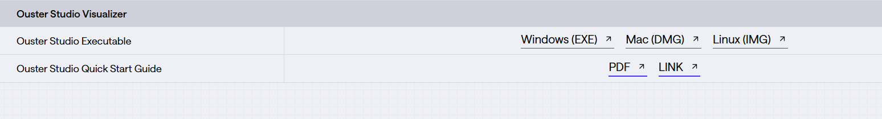

- Open Ouster studio - Click open local recording

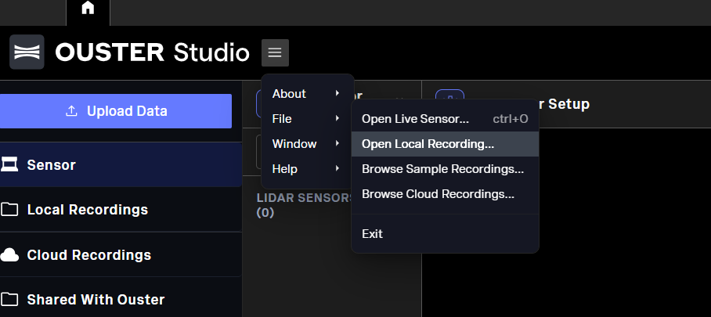

- Drop .pcap and .json file
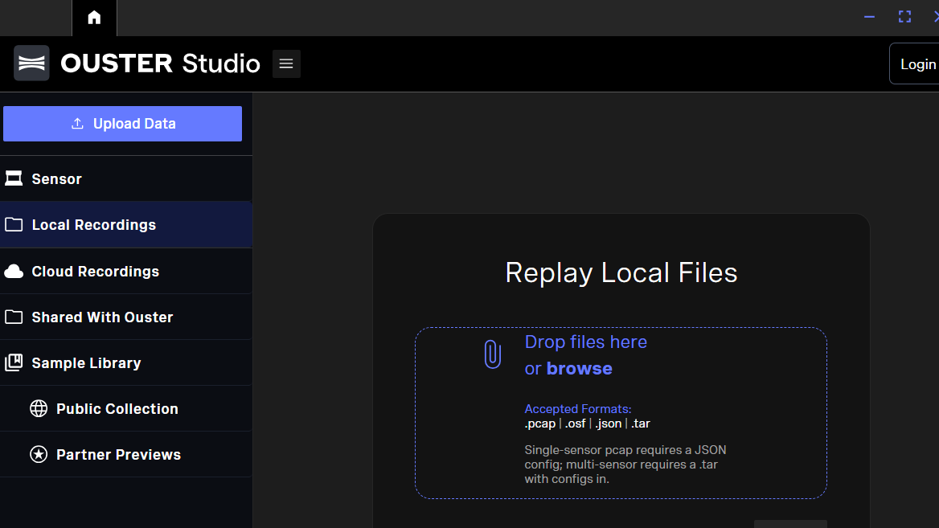

- You should see the pointcloud of scene
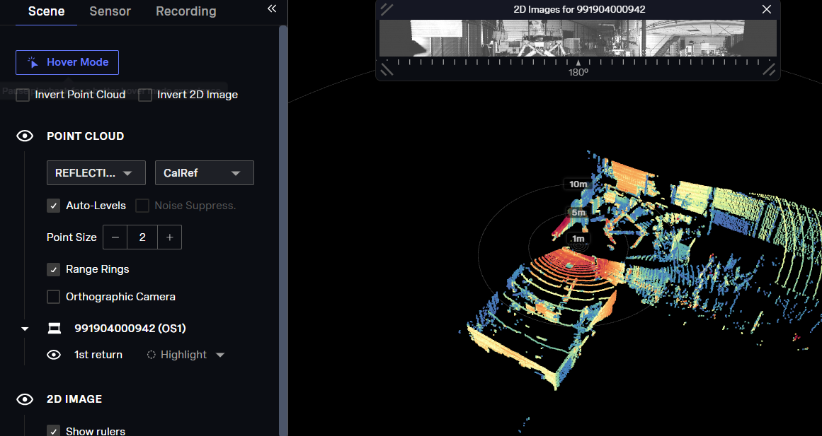

Reference:
Ouster home page - https://static.ouster.dev/sensor-docs/index.html
Download - https://ouster.com/downloads

Install dependencies for point cloud processing

- Create venv - e.g. lidar
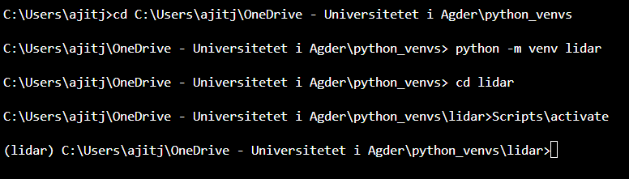
- Install python sdk - https://pypi.org/project/ouster-sdk/
- Install dependencies
C:\....\lidar> pip install requirements-lidar.txt
- Open ouster-lidar2_class_student.ipynb
  - Go through each cell and understand how to use open3D and associated libraries and syntax
    - Read .ply, .pcd files
    - Visualize pcd
    - Normalize
    - Clustering – DBSCAN, K-means
    - RANSAC, pose estimation
    - Plane equation and distances
  - Perform the tasks given in some cells.

3. Relevant Information

Ouster home page - https://static.ouster.dev/sensor-docs/index.html
Download - https://ouster.com/downloads

